SMART HOME ENERGY MANAGEMENT SYSTEM

aPravin Raja bRahul Ravi
BE.Electrical And Electroincs Engineering BE.Electrical And Electroincs Engineering
M.Kumarasamy College of Enginnering M.Kumarasamy College of Enginnering
Karur , Tamil Nadu Karur , Tamil Nadu
927623bee075@mkce.ac.in 927623bee081@mkce.ac.in

cSujithkumar Selvam dYuvaraj Mani
BE.Electrical And Electroincs Engineering BE.Electrical And Electroincs Engineering
M.Kumarasamy College of Enginnering M.Kumarasamy College of Enginnering
Karur , Tamil Nadu Karur , Tamil Nadu
927623bee107@mkce.ac.in 927623bee107@mkce.ac.in

Abstract — The steep increase in the electricity demand, and the environmental awareness and the high cost of energy have left the need to have the introduction of the energy management systems within the homes. Integration of machine learning (ML) algorithm within a Smart Home Energy Management System (SHEMS) is the resultant effective and automatic means of optimizing the home energy consumption. With the help of this project, a ML-based SHEMS is presented that monitors the power usage in real-time, analyzes previous consumption trends, and, calculating how much energy can be used at the minimal, it will run the home appliances automatically. The system, first of all, gathers data about power use, environmental conditions, and user behavior in real-time with the help of sensors, smart meters, and IoT enabled appliances. The ML algorithms such as regression models, decision trees, or neural networks then use this data to predict the consumption of energy and identify inefficient patterns of its use. Secondly, the system takes a position that both schedules and regulates the appliances in a manner that minimizes the amount of energy it consumes during the peak hours and utilizes the most of energy resources like solar energy, when they are available. Further, the system enables the demand response mechanisms which enable the shifting of the loads to react to the alterations of the tariffs and the grid conditions. Inclusion of the preference of the user in the model will ensure that the comfort of the users will not be compromised on in an effort to save energy. The mobile or web interface provides the real-time monitoring, comparative analytics, anomaly detection, and personal suggestions, which helps the users to have a look at the insights and control of their consumption.
.Keywords — Promise Informatics, Tesla Energy, UniversalQuant, IoT Energy exchange, Smart meter, demand response, predictive analytics, appliance management, real-time feedback, automation, environmental accountability, consumer comfort, data analytics, sustainable living.
I .INTRODUCTION
The demand of electricity is on the rise and energy prices are constantly rising, as the global society continues to place an additional stress on sustainability, therefore, efficiency in energy management has become the highest priority in the contemporary home. When it comes to traditional homes, it is best that they rely on manual ways to monitor and control the situation that typically leads to using an inordinate amount of energy, increased power bills as compared to the norm and resources already available just being used inefficiently. The revolutionary concept of smart home that has risen due to the quick pace of smart developments can provide a solution to the problem. Smart Home Energy Management Systems (SHEMS) are designed to intelligently perform three operations namely, monitoring, controlling as well as maximising energy use in the residential quarters of the consumers hence these systems are both economical and environmentally friendly. The enhancement of these systems with machine learning as it provides them with the ability to make decisions based on the information and not on the logic alone, it is these data of what has been previously applied, the weather and how the appliances have behaved. With sensor data, the outputs of smart meters, and devices with IoT, machine learning model can predict the amount of energy used at a particular date and hour with high precision; they are also able to identify losses and program the residential appliances on autopilot. This wondrous capacity of predicting not only serves the purpose of reducing the amount of energy consumed during the peak hours, but also enables the solar power, say, and the utilisation of the photovoltaic panels such that, homes become more energy-reliant in as far as this eco-friendly energy is concerned and less reliant on the grid. In addition to that, the Smart Home Energy Management Systems provide users with the ability to track, give personalized recommendations and achieve real-time control or management. Mobile and web can help the owners to effectively monitor their energy consumption, examine the patterns, and regulate the schedule of their appliances. It is also a system that gives consideration to the preferences of the users hence energy is saved without compromising on behalf of comfort or way of life. Because the energy consumed varies with the weather and habits of the people and not at every place, the learning and adaptation of machine learning algorithm continues, thereby, always advancing performance of the system. Other than the efficiency of household energy, SHEMS can also assist in achieving greater aims of the community, including reducing carbon emissions, enabling the transition to the smart grid, and encouraging sustainable living practices. Governments of the world and their energy-related industries are more than willing to embrace smart home technologies as a tool of providing the energy transition of the future. The proposed Smart Home Energy Management System is an invention that will result in smart, eco-friendly but future-ready residential settings through the application of such technologies as machine learning, IoT, and automation.

II. LITERATURE SURVEY

The growth in the application of smart technologies within the home environment has been of the focal point in a multitude of research studies on the topic of intelligent energy management systems. Initially, sensor monitoring captured the majority of the focus whereby systems would compute the real-time information of the energy consumption but with very little or no decision making facilities. Nowadays, with the popular use of IoT-powered devices, a growing number of researchers are considering energy consumption automation to not only save some power of homes, but also make them easier to use. This is because of internet connection with these gadgets, which has now developed Smart Home Energy Management System (SHEMS), which would not have been able to come about without these technologies and hence agreeing to capture data uninterrupted, remote control of appliances, real time notifications. It has been observed that the discussion to a great extent has shifted to how artificial intelligence (AI) methods could be applied to optimize energy, with the substantial use of the predictive component of the analytics. The research activities by Kumar et al. (2020) confirmed the stance of employing machine learning algorithms, that is, regression, neural networks, which indicate the direction towards effective prediction of household energy demand, thereby resulting in the reduction of peak load and improved scheduling. In a similar case, Patel and Singh (2021) did the same but with the goal of identifying the unproductive appliances and the patterns of consumption as a result, to validate the most optimal energy-saving interventions that can be deployed. The mentioned literature dwells upon the sunny future of machine learning in both understanding consumer behavior and increasing automation. In addition, there have been speculations as to the future of inclusion of clean and renewable sources of energy in the domestic energy management portfolio by the authors. Rana et al. (2022) explicitly defined that the fact that solar power prediction was used in combination with load shifting activities as a result of the smart controller is particularly important to the energy efficiency of smart home industry. The machine learning models were presented as the chief players in the production forecasting of solar energy, and the weather conditions are the sources of the data and allow the system to request power produced by clean sources whenever the power is available. With that kind of a step, the number of central heating demands is greatly reduced, and so, it will help in energy-saving activities that are suitable towards the environment. Recent papers have also featured the discussion of the introduction of demand response (DR) tools. In their works, Zhang and Li (2023) discovered that it might be through reinforcement learning strategies that the switch-off or on of appliances in households may be achieved during a high-tariff period without the user taken any steps or become less comfortable. In short, using machine learning, it is possible to say that a timely and smooth interaction between households and the smart grid can be achieved and thus can guarantee grid stability, as well as reduce the chances of the power system being overloaded. Although there are several advances that have been mentioned in the literature, a few problems like data privacy, accuracy of the model, and user acceptance are still unaddressed. Despite these limitations, the sum of the research works is more than just evidence of the efficacy of ML-based SHEMS to provide a viable alternative solution to the implementation of smart, green as well as cost-effective approaches to the management of the residential energy supply.

III. INTERFACE DESCRIPTION

The most central user interface of the ML-based Smart Home Energy Management System is the instrument panel used to monitor and control the smart home energy. It will target to provide the user with the opportunity to see in real-time and graphically the amount of energy used in his home as well as the convenience of controlling the appliances connected to the network. The interface is the intermediary between the user, IoT devices and machine learning algorithms and in so doing it transforms difficult energy data into an easily understandable form and can be acted upon. Essentially, the interface allows users to ensure that they can impact the surrounding world through informed decision making, energy saving and comfort with minimum manual interference. There are several interactive modules of the interface. The Real-Time Consumption Panel shows direct power consumption, which it updates based on smart meters and the Internet of Things sensors. Visual impressions like figures, maps, and charts are all prepared to ensure that people will see the energy consumption of each of the appliances or machines in numbers. Conversely, the data analytics are being conducted in the background by the machine learning system and the interface identifies by this very method abnormal consumption and overall, it identifies all the instances of energy wastages by generating notifications, messages, alerts, etc. The major portion of the control panel is the Appliance Control Center. The functions that can be executed by the users are: activating or deactivating of the appliances, adjustment of the running information and at will automated mode gets activated. The effect of automation is that the module determines the optimum use of appliances using hardwired poll data (weather, forecast), using the tariff and exploitation of solar energy depending on the predicted consumption behavior. Whenever a user desires to override the automatic mode, he is allowed to do this through the manual control button on the interface any time. Otherwise, the Energy Forecast and Insights Panel informs the users about the following energy consumption time (in hours or days). These would be the predictions of the machine learning models that would assist the users to estimate their energy requirements and plan to utilize devices in advance. Other elements introduced by the interface include the form of insights peaks of usage, energy-saving tips, comparison tables, and monthly consumption summaries. This kind of analysis will provide the households with a chance to identify the non-efficient appliances and implement the habits that will help to reduce their energy bills. The dashboard also entirety has a Solar Monitoring Panel (where applicable) as a provision to help in integrating renewable energy. Information like real time generation of solar energy, battery condition (when energy is stored or not) and share of renewable sources is also given to the user. This way, users can use the solar energy to its full capacity and reduce their reliance on the grid. It is also much concerned over the aspect of accessibility and user experience, which is why it has got tidy layout, appealing design, responsive graphics and easy navigation. Whether you interact with the system through mobile application, web browser or smart home display, the system ensures that interaction and functioning of functions regardless of platform is not interrupted. In brief, Smart Home Energy Monitoring and Control Dashboard is a smart, engaging, and friendly interface that significantly eases the work of the entire energy management apparatus. As a matter of fact, the UI is the interface which connects the user with the system and therefore, it contains integrated real time data display, predictive analytics, automated control and user customization in layman terms it is the facilitator of an energy efficient, sustainable and intelligent living environments.

IV.METHODOLGY

The Smart Home Energy Management System (SHEMS) focuses on machine learning, IoT integration, and energy optimization algorithms among other processes to transform raw data about the energy usage of households into intelligent and automated decisions. The entire procedure consists of the following key procedures: System Architecture Design, Data Acquisition, Data Preprocessing and Feature Engineering, Machine Learning Model Development, Energy Consumption Prediction, Load Scheduling and Optimization, Real Time Monitoring and Control, and Evaluation and Performance Analysis. These steps are interconnected so that the system will be able to forecast well, manage the appliances effectively, and make the general outcome of decreasing energy consumption possible.

System Architecture Design

The working mechanism of the Smart Home Energy Management System has been described in the section, which was obtained by parts.

The following elements constitute the system design; sensors, smart meters, microcontrollers, cloud servers, machine learning module and user interfaces. Installation of sensors and smart devices in different locations oversee energy usage, temperature, presence and absence of people, and the condition of appliances. These devices are able to communicate with each other over IoT communication protocols such as Wi-Fi, ZigBee or MQTT and relay data to a central gateway (ex: ESP32, Raspberry Pi or Home Hub). The information is collected and passed on by the gateway to the cloud or local edge server where machine learning is used in processing. Also, the feedback loop is incorporated in the system design. The smart switches and appliances receive control signals after the prediction and optimization decisions are made. As an illustration, the system can be used to shut down the power supply to the loads that are not in use, it can shift the heavy loads to the times when electricity is less expensive or it can use electricity on the solar panels that have been stored during the high tariffs. There is also the mobile/web dashboard in the system which displays real time energy used, the future expected to be used, proposed activities, and analysis of cost. The system layout effectively fulfills the role of a backbone, which is the element of the system which glues the sensors, analytics, decision-making modules, and the automated control, and thus offers a intelligent and functional home energy ecosystem.

Data Acquisition

There is no way of doing things without data acquisition. The reason is that, machine learning models are highly reliant on the data that they are being provided with and that such data should be of high quality and be accurate. One of them is that the information regarding the energy consumption will be acquired via smart meters which will be installed not only in the main connecting board but also in the separate devices. Simultaneously, these meters measure voltage, current, power factor and load consumed at fixed intervals (1-60 seconds) in order to accomplish the same. Besides, sensors can also be used to retrieve information involving the room temperature, the humidity, and the source of the light. The system can use occupancy (motion sensors or RFID tags) information in order to comprehend the presence of users and therefore prevent unnecessary power consumption. As an example, at the houses where there is a solar panel, the information on inverters and battery storage facilities should be collected to monitor the production of renewable energy. After that, all these data are transmitted to the central server using a communication protocol. A time-stamped database is developed in order to hold energy usage tendencies of daily, weekly, and monthly information. The data set is very rich. It enables the machine learning system to discover which appliances use the highest amount of energy, when the energy use is the highest, and how the environmental changes influence the energy demand.

Data Preprocessing/ Feature Engineering.

The data is preprocessed prior to being introduced into the machine learning model, and it is done to the detriment of accuracy and performance. Initial stages of processing used include cleaning up of the dataset. In this case, there are values that are missing, noisy data are repaired, abnormal data are smoothed, and data is normalized. As is well known, energy consumption as a concept is not constant and it depends on the season and the weather, time-related characteristics are also included, the hour of the day, day of the week, season, and holidays. The uncovering of the important patterns is done in the work known as feature engineering. As an example, it is possible to consider averaging the daily consumption, the maximum usage rates, the load transient and even the idle power consumption. One of the methods that can be used to test the relationship between sensor readings and power consumption is when through correlation analysis. This step contributes tremendously to the precision of the machine learning models insofar as their prediction is involved by giving them well polished and classy data that illustrate user behavior, appliance features and environment impact.

V.RESULT AND DISCUSSION

Smart Home Energy management System furnished with machine learning provides an innovative and energy efficient method of reducing the amount of power in use in a domestic appliance and simultaneously maintaining the comfort of the user. Working together with the assistance of IoT-based sensors, predictive analytics, and automated load control, the system accurately It measures the historical consumption trend, forecasts the energy requirements and control the usage of the appliances in real-time. Consequently, energy is saved, renewables like solar energy are used in a better way and pollution is limited. 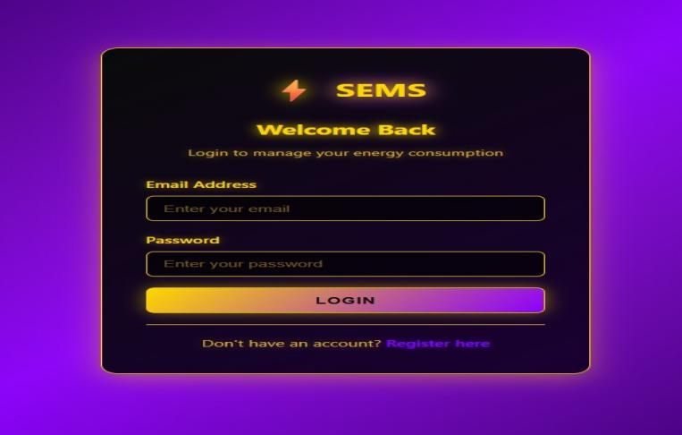
Fig.Login Page

A smooth and contemporary, attractive, and visible login screen of a Smart Energy Management System (SEMS) is displayed in the picture. The implementation of the design is a technology-focused one thus its dark-colored theme featuring neon yellow and purple gradients that shimmer and shine provides it with a clean futuristic feel. The visual component of the connotation of the SEMS logo that most strongly expresses the conception of energy management is the lightning icon on the top. The interface is welcoming the users into logging in so that they can have access to their energy consumption tracking and control. Email and password entry forms are present with a bright gradient being the most conspicuous button being the login button. The form has a link at the bottom where new users can create an account, hence, this page is user-friendly and functional. The overall visual impression of the design is the exemplary combination of beauty and convenience and, therefore, an incredible entry mode into the application.
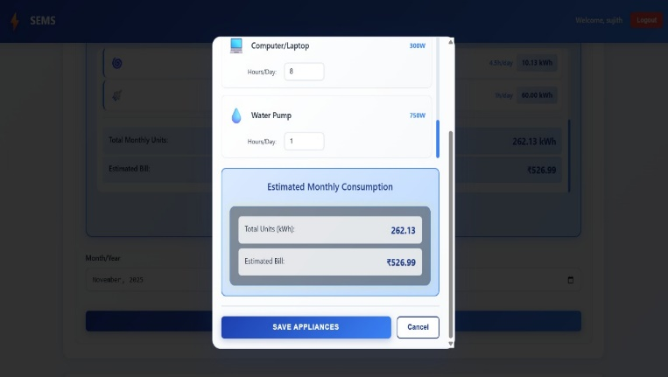
Fig.Interface

This picture is of Smart Energy Management System (SEMS) Electricity Bill Calculation Dashboard that tracks the normal consumptions of power by users in an effortless and uncomplicated manner by utilizing analytical processes. The users are required to first key in their power consumption in units after which they pick a month and the year and the system then allows the calculation of the bill to be done automatically. The entire page with the most emphasis is the Bill Summary area where the total units, the total bill, and the month selected is written in a total yellow bright colored card. Below its position is the advanced analytics category on the dashboard that unveils the Next Month Prediction where the consumption of the past months is fed by the system which gives the Bill of the coming month and the Bill Comparison section that indicates how the current bill is different compared to the previous one here it is seen that there is a reduction in the bill of 22.58 percent. It is maintained as a modern design with clean dark theme with neon colors that keeps the user interface comfortable, on the eye and, at the same time, the detailed insights are made available to the users to help them get a better picture about their consumption and, therefore, bring it under control.
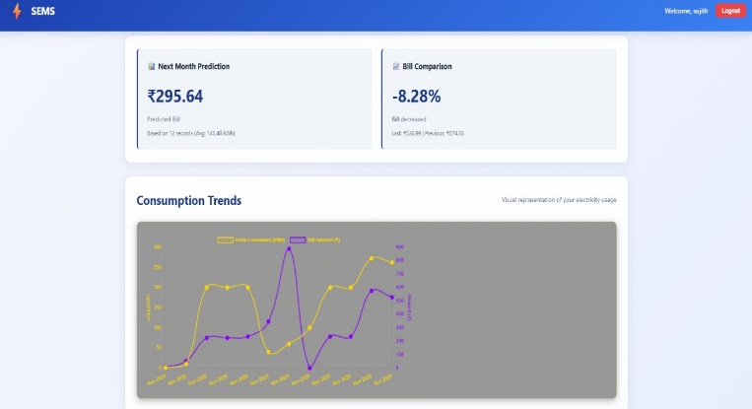
Fig.Graphical View

The picture represents the Consumption Trends component of the Smart Energy Management System (SEMS) that shows in a visual way to the user the analysis of the previously used electricity consumption. The graph has two significant curves that include the green curve that represents the Units Consumed (kWh) and the blue curve that represents the corresponding Bill Amount ([?]) in each of the recorded months. The system is jointly plotting the two values to enable the users understand easily the variations in their power consumptions that fail to warrant their monthly electricity bills. The rounded curves will lead to the instances of peak periods, sharp decline, and seasonal changes, hence providing the users with the opportunity to discover the wasteful consumption patterns. Its dark-themed background and the neon color lines not only make the chart a beauty, but also very readable therefore giving the users an idea of how their energy behaves over time; this is an intuitive insight and a valuable one to make.
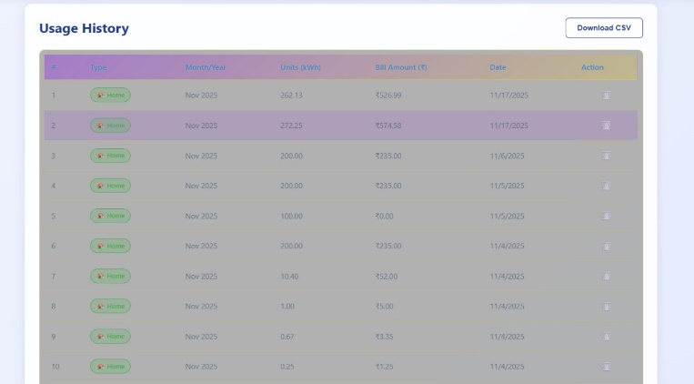
Fig.Table View

The image that was on display was the Usage History section in the Smart Energy Management System (SEMS) in which all the previous history of the energy consumption has been maintained in a good order in the form of tables. Indeed, every record has the month and the year, the units used, the amount of bill, and the specific date when the record was inserted. With such a straight forward well-organized presentation, the users can get free time to identify what their previous habits of energy consumption are as well as comparing the bills of different months. The table layout adopts a dark format that has yellow tone as the highlights to ensure that it is easier to read the contents by the users. On the top-right, users have a Download CSV button that allows them to store their whole usage history on their computer in CSV file format to be used in future work or record-keeping. Overall, this section is a highly efficient tool whereby users are permitted to track, monitor, and calculate their energy usage within a predetermined time, in a single site.

VI.CONCLUSION

Smart Energy Management System (SEMS) is a step forward towards the new world of home electricity monitoring and bringing the concept of energy saving to the consumers through the lenses of the use of modern digital processes. The system is united by convenient interfaces, real-time analytics, automated generation of utility bills, predictive modeling with advanced modeling methods, and data storage to establish the entire environment making energy management more efficient. Using them, the consumers will have a clear understanding of how their routine becomes the major cause of energy use up and what they will have as the sum total of what they pay monthly. Immediately paid bills relating to units consumed provide the consumers with immediate monetary acknowledgment as the prediction algorithm tracks the potential consumption by machine learning thus prompting the consumers to to organize their consumption in advance and control it independent of others. This is one of the great advantages of such visual components as graphs as it can naturally express the consumption habits in terms of minutes and the visualization can be further improved by addition of more additional graphs at different angles that can better represent the same. It allows users to easily identify months of high usage, the analysis of changes throughout the year, or sudden spikes, thereby providing them with an opportunity to demand corrective actions and start transforming their routines to the ones, which are more energy-friendly. Moreover, the recording part is satisfied with specific monthly data therefore providing long-term storage and chances to conduct comparisons with certain degree of education. This history combined with accessible downloadable reports will help in comprehensive examination and also in absolute revelation of the energy that is a critical attribute to the households who are eager to reduce their costs or generate a green existence. Besides, this product is properly planned and designed to be as usable as possible that means easy navigation, easy visualization, and a responsive interface to provide the accessibility to the users of all types. The application of neon accent on the dark theme makes the system be slick and cutting-edge in addition to increasing the legibility thereby reducing the eye strain during extended use. Providing the interesting and visually impressive interface, the platform will also ensure that users will not get bored and they will be ready to accept the challenge to handle the consumption of their own electricity. Additionally, such function as output percentages of bills is also essential to give the users an understanding of the impact of their saving plans in the long run. SEMS is one such technology intervention that is capable of transforming the daily routine tasks such as electricity monitoring into simple, smart and automated tasks. By adopting computing, the system also provides the users with power to make wise decisions, reduce wastage, and have efficient and sustainable use of electricity. This project, besides demonstrating the potential of digitized energy management, supplies, serves as a precursor to the future introduction of the corresponding ideas, such as appliance-level monitoring, smart devices automation, and integration of renewable energy. With SEMS, people will be able to make ample strides in terms of saving money, saving the environment, and ensuring the sustainability of energy in the long run.

VI.REFERENCES

- Ayyasamy, E., & Kalaivani, R. (2021). IoT-based smart energy monitoring systems: A comprehensive review. International Journal of Electrical and Computer Engineering, 11(5), 3924–3932.A. A. El-Sebaii and S. M. Shalaby, “Solar drying of agricultural products: A review,” Renew. Sustain. Energy Rev., vol. 16, no. 1, pp. 37–43, 2012.
- Khan, M. J., Jayaweera, S. K., & Gamage, G. B. (2020). Machine learning-based energy consumption prediction for smart homes. IEEE Access, 8, 139074–139086.M. A. Leon, S. Kumar, and S. C. Bhattacharya, “A comprehensive procedure for performance evaluation of solar food dryers,” Renew. Sustain. Energy Rev., vol. 6, no. 4, pp. 367–393, 2002.
- Rault, T., Bouabdallah, A., & Challal, Y. (2017). Energy efficiency in IoT: A survey. Computer Networks, 101, 129–154.P. K. S. Rathore and N. L. Panwar, “Experimental studies on heat storage materials for solar air heating applications,” Renew. Sustain. Energy Rev., vol. 15, no. 8, pp. 3823–3836, 2011.
- Rault, T., Bouabdallah, A., & Challal, Y. (2017). Energy efficiency in IoT: A survey. Computer Networks, 101, 129–154.Z. Li and Y. Zhang, “IoT-based monitoring system for smart agriculture drying process,” Int. J. Adv. Comput. Sci. Appl., vol. 11, no. 5, pp. 210–217, 2020.
- Wen, L., Zhou, K., & Yang, S. (2020). Load profiling and prediction of residential smart meters using machine learning techniques. Electric Power Systems Research, 181, 106157.
- Gungor, V. C., Sahin, D., Kocak, T., & Erturk, S. (2013). A survey on smart grid potential applications and communication requirements. IEEE Transactions on Industrial Informatics, 9(1), 28–42.

